**Smart Billing System For Water Suppliers**

**ABSTRACT**

“If there is magic on this planet, it is contained in water”, as American philosopher Loren Eiseley rightly said, ‘water’ is the hot potato of our beloved Bengaluru. Our childhood summer holidays were filled with dramatized inter-sate fights ! Everyone wants water but no one are ready to efficiently use it.

Our project is concentrating solely on analyzing the usage of water in a single house. Kaveri water is pumped and transported over a distance of 100 km, from the ‘Krishna Raja Sagar’ dam (built by Sir. M Vishweshwaraiah) in Mysore. That water is supplied to our houses and we are charged according our usage. But the question is, are we being charged justly ?

The answer is a big NO.

The charges for basic uses like drinking, bathing, cooking etc. have to be normal. But what accounts for the water being used for Vehicle Cleaning, Gardening etc.? We have to be charged according to our usage of water for different purposes differently.

This is where our project comes into picture. We install TI products to the individual house which we want to monitor and collect data of the normal water usage of that house in the first month. Along with it, we also monitor how much of water is being used for different purposes, the average time for which the tap is open. This helps us to estimate wastage quantity and warn them !

The 2nd month onwards, we exactly know their needs and notify them about excess usage and bill accordingly. We then charge **₹ 1** for every 10 liters of water used for non-domestic purpose

**Project Description:**

Nowadays several fill stations are set up across the cities to operate water tanker service delivering water to all the local households. Tankers get registered and a card is issued for the users which can be used for payments. They can also top-up their card through the mobile application. Each fill station is equipped with hand-held devices (based on the number of pumps in the fill station). These hand-held devices have the facility to read/write into RFID based smart cards as well as WIFI modem to communicate with the central server over the cloud. This data can then be viewed by the users on their respective mobile applications connected to the cloud.

**Technical Architecture:**

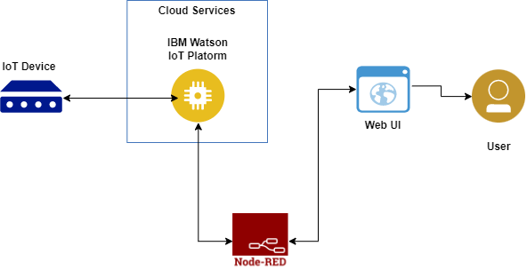

**PROJECT OBJECTIVES**

By the end of the project, you will:

* Gain knowledge of Watson IoT Platform
* Explore Wokwi Platform
* Explore the devices and its simulation of the wokwi platform.
* Explore the libraries present in Wokwi.
* Will be able to code to connect the devices across the cloud platform.
* Connecting the devices on wokwi to the IoT platform device to exchange the sensor data.
* Gain knowledge of creating devices and platforms using IBM Watson IoT Platform.
* Gain knowledge of web application development through node-red.